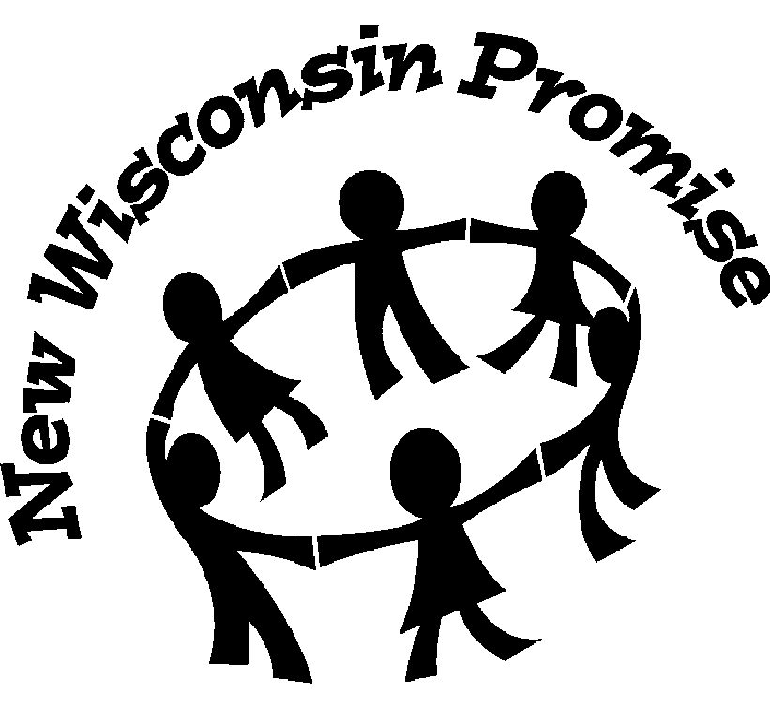 |  | Wisconsin Department of Public Instruction  CONTINUING EDUCATION ACTIVITY REPORT  PI-2453 (Rev. 09-04) |  |  |  |  | INSTRUCTIONS: Complete and submit annually to Validator along with the Annual Summation of Continuing Education Activities, PI-2454. Refer to the Certification Manual for Wisconsin Public Library Directors for assistance.
 | Name Last, First, Middle
 | Mailing Address Street, City, State, Zip
 |  |  |  |  | I. CONTINUING EDUCATION ACTIVITY DESCRIPTION
Title of Program
Adolescent Literacy Initiative
Afternoon session: Adolescent Readers
Description of Program
Explore how adolescents view reading, the challenges facing teens in continuing to value reading, and what we can do to help develop life-long readers.

 | Relationship of Program to Present Position or Career Advancement
 | Activity Dates |  |  | Location |  |  |  |  |  | Total Contact Hours
 | From  5/19/2009 |  | To | Ripon Public Library, Ripon, WI |  |  |  |  |  | 2
Provider if applicable
Winnefox Library System
 | Category Check only one and attach written summary if applicable
A. Credit Continuing Education (attach formal documentation from the sponsoring agency)
B. Noncredit Continuing Education
C. Self-directed Continuing Education
 |  |  |  |  |  | II. SIGNATURE
 | I HEREBY CERTIFY that the information provided is true and correct to the best of my knowledge.
 | Signature of Participant  ➢ |  |  |  |  |  |  |  |  |  | Date Mo./Day/Yr.

